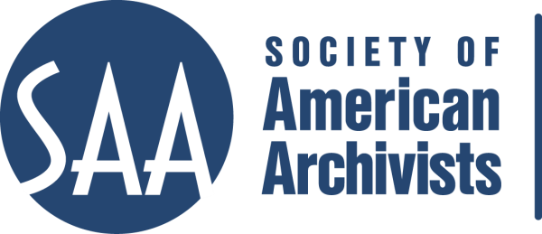
CE Workshop Evaluation Form
Arrangement and Description Track

Workshop Evaluation Form:

Title | Project Management for Archivists
Reviewer: | James Roth
Directions:
- Quantitative: Each item below begins with a bolded statement. Score each with a 1-5 ranking to indicate your assessment of the veracity of that statement based on your review of workshop overviews/agendas, evaluations, and other materials.
- Qualitative: In the comments section for each item below, please respond to the additional questions posed and any related issues that this workshop raises for you.
- Provide any additional assessments or comments not relevant to one of the specific, numbered areas in the space provided following the table.

Please place an “x” in the appropriate column, use 1=low, undesirable, to 5=high, excellent. |  |  | 1 | 2 | 3 | 4 | 5
1. Does the content appeal to its specified audience? Does it indicate specific categories of archivists and/or levels of expertise to assist potential participants in determining the workshop's relevance for them?  Comments: This should appeal to the specified audience. Yes, it is very specific, geared towards project team members. Perhaps it should add administrators who oversee projects/project managers. |  |  |  |  |  |  | X
2. To what extent does the subject matter reflect current archival practices and theory commonly accepted in the profession?  Comments: This is more about management theory and not archival practices per se. HOWEVER, every Archivist should take this course. I want to take this course! This fits so well with how to plan for a processing (A+D) project. |  |  |  |  |  |  | X
3.. How relevant/appropriate are the teaching and delivery methodologies (lecture, video, PowerPoint, exercises, film, audiotape, discussion, simulation, case study, opportunities for in-course feedback, etc.) to the articulated goals and objectives, and to the content?"  Comments: Lecture, handout, and discussion/hands-on exercises. Very relevant/appropriate. The handout is exceptional! It looks professionally done. |  |  |  |  |  |  | X
4. How workable is the time line or agenda for the course? Is there sufficient detail to indicate how the workshop will evolve? Does it allow sufficient time for active engagement between course participants and the instructor(s)?  Comments: Perfect 1 day. Well balance and seems to detail how the workshop evolves over the course of the day. |  |  |  |  |  |  | X
5. To what degree does the list of assigned readings support the content of the proposal?  Comments: No real assigned readings, but the bibliography is exceptional! Well balanced set of articles to choose from. Very impressive. |  |  |  |  |  |  | X
6. Does the presentation support the Learning Outcomes in the descriptions?  Comments: Yes it meets the Workshop Objectives, but does not specifically state Learning Outcomes. |  |  |  |  |  | X
 | A&D Track Considerations
 | 1.Does this content bridge, enhance, and/or build on other workshops (If so, please name) | This workshop doesn’t build on the content of other workshops, but it does build on creating good management structure for A and D projects. Any new processing archivist who is put in charge of a large scale project should take this course.
 | 2.Does this build on other workshops not on the list? | I think this complements “Arrangement and Description of Manuscripts Collections”, “Basic Imaging: How to Do a Small Digitization Project”, and any other workshop that outlines a specific project based approach.
 | 3 Should this be part of the A&D Track? | Yes, I believe it should be a part of the A&D track.
 | 4.Where would this workshop fall in the sequence of an A&D track? | It should be beginner/intermediate level.
 | Why? | Helpful to both new archivists put in charge of a project, or intermediate archivists who are taking over a department and need to hone their management skills (excluding supervision/management issues).
 | 5. What tier does this workshop fall in? (See attached tiers) | Tactical and Strategic.
 | 6. Target Audience | Practicing Archivists: beginning and intermediate. Perhaps even new managers and administrators.
 | 7. Is the suggested prior “experience/knowledge” appropriate? | I couldn’t find “experience/knowledge” listed. I don’t think it requires prior experience/knowledge.
 | 8. Learning Outcomes:  Are they appropriate and/or relevant? | Stated as Workshop Objectives. Yes, appropriate and relevant..
 | 9. What should they be?  Please list learning outcomes. | Stated as Workshop Objectives:  • understand basic project management concepts and the project life cycle;  • be able to utilize simple but effective project management tools and techniques; and  • be able to evaluate project outcomes and disseminate project information.  • recognize how positive personnel management adds to a successful project;  • begin to understand how all of your experiences, personal and professional, will help when managing projects; and  • learn to be comfortable with your project management role.
 | 10. Can you make suggestions for competencies this workshop would fulfill?
 | 11. Would parts of the content lend themselves to a different format? | Check one: Webinar: - 30 minute - 90minute In person: - 1/2 day - 1 day - 2 day
 | 12. Which parts? | n/a
 | 13. Does it lend itself to repurposing as an audio CD? | no
 | Which parts? | n/a

Other comments:
I want to take this course! The handout impressed me greatly. I think every archivist who is put in charge of a project should take this workshop.

